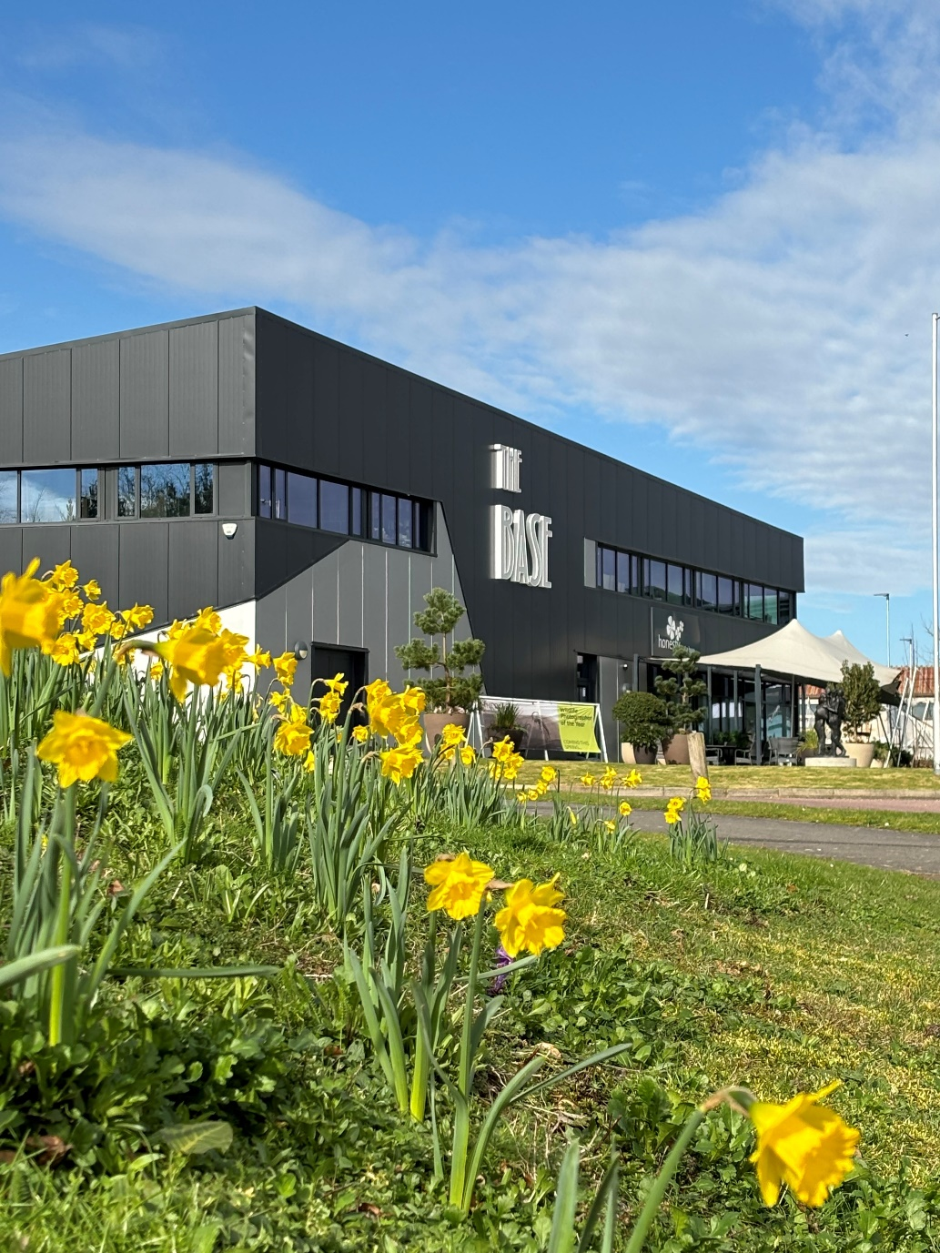
OTTOPIA
Visual Story
Hello, we are very much looking forward to welcoming you to The Base. These notes are for you to read before your visit to OTTOPIA at The Base. They tell you more about our building and what happens inside, so that you will know what to expect.

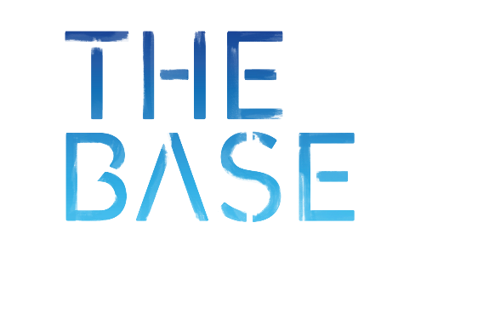

Welcome to The Base
This is the front entrance to The Base. The first door will open automatically when you approach it, then turn left and go through the second automatic door on the left-hand side.
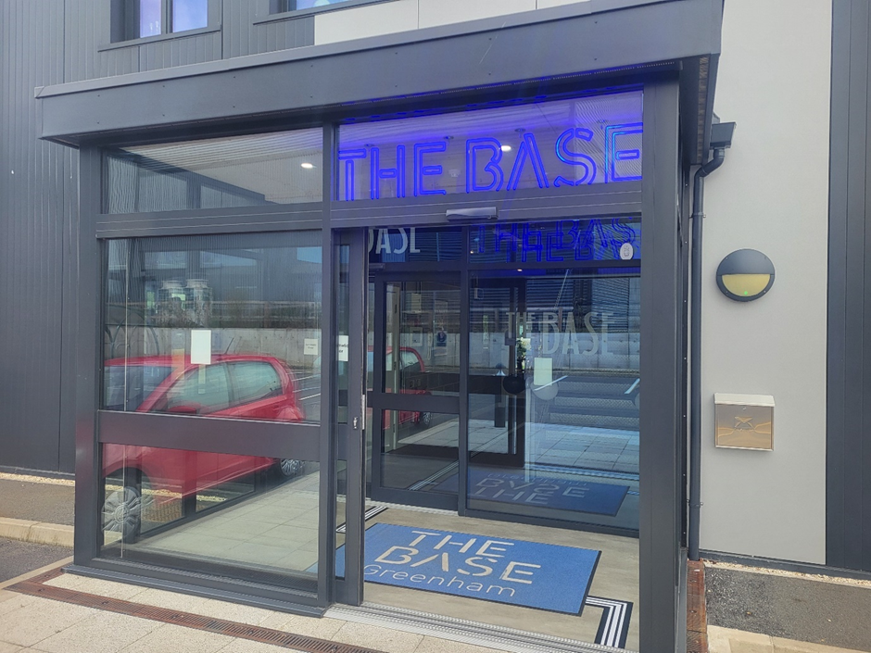

When you walk through the door, you can follow the black and white stripy line. This will take you to OTTOPIA in The Gallery.
There are also signs to help you find your way around.
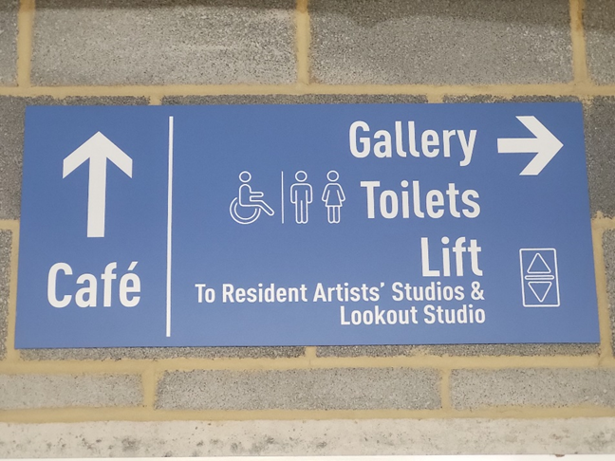
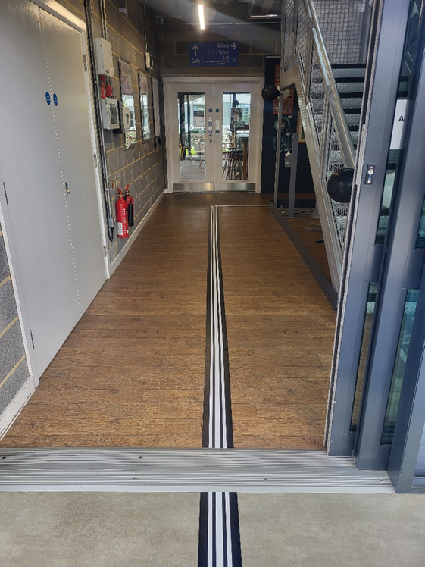
TOILETS
We have turned off all hand dryers for the Relaxed Day and provided paper hand towels instead.

There are toilets just by the entrance to OTTOPIA. | Upstairs, they’re halfway down the corridor.
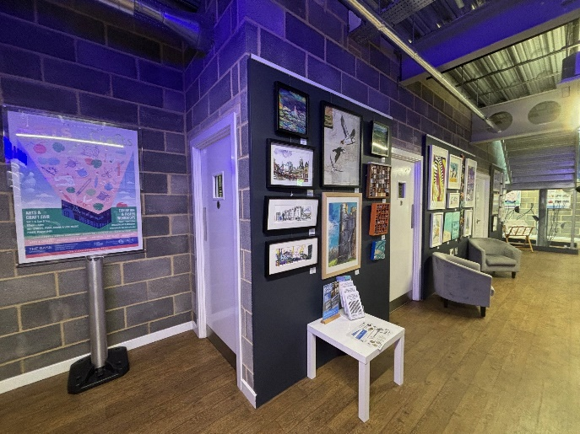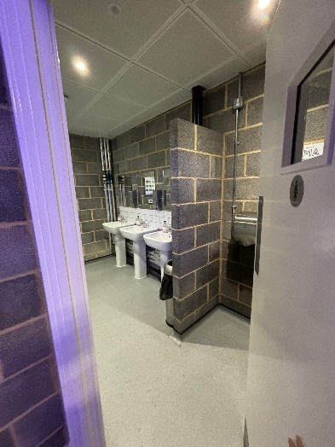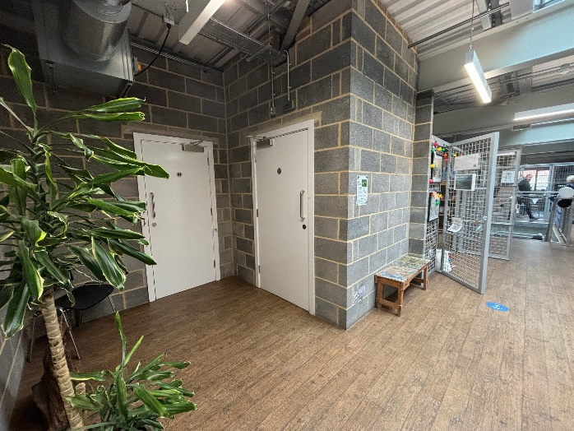

If you are unable to locate the toilets, please ask a member of the team. There are also accessible toilet facilities available on both the ground and first floors.

A gallery assistant will be at the desk to greet you and give you a guidebook. There might be a very short wait before you go in.

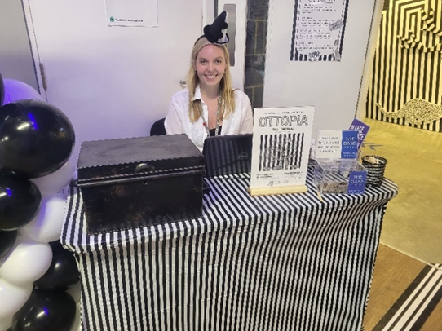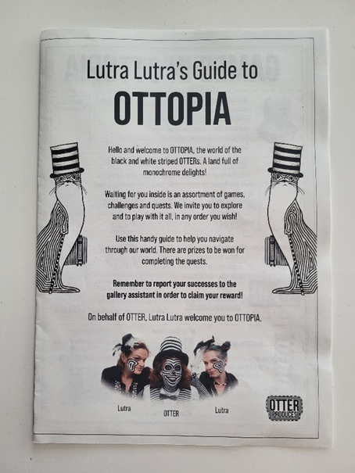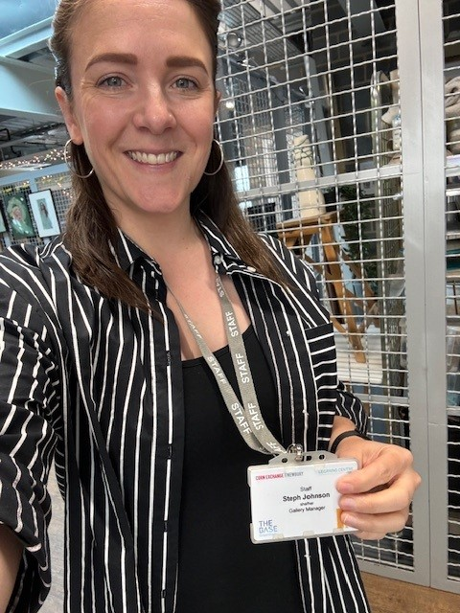

If you have any questions during your visit, speak to a member of our team (who all wear lanyards) - we are happy to help in any way we can. Or you can write a message down and show them if you would prefer.

As you walk into OTTOPIA, this is what you will see first...
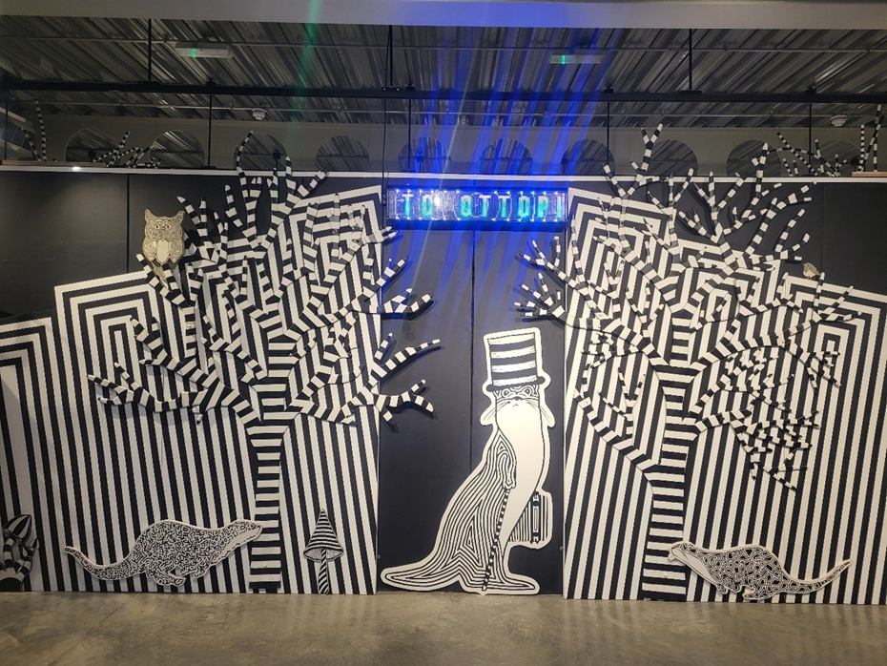

There might be other people visiting OTTOPIA at the same time as you. Sometimes it can be noisy in OTTOPIA. You will hear other people talking and some OTTOPIA characters talking on a video.

You can explore OTTOPIA in any order that you like. There are games to play, buttons to press and lots to look at.

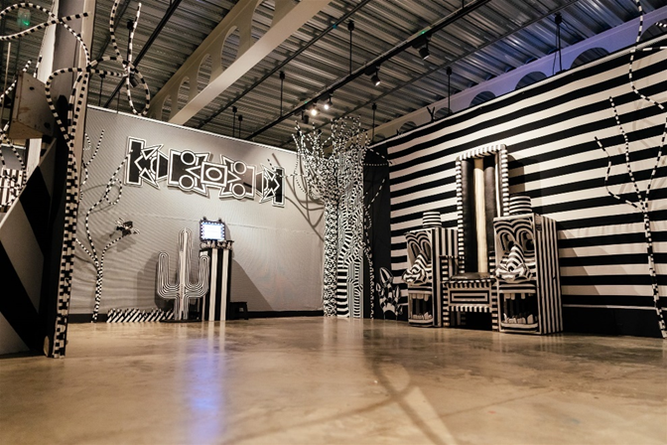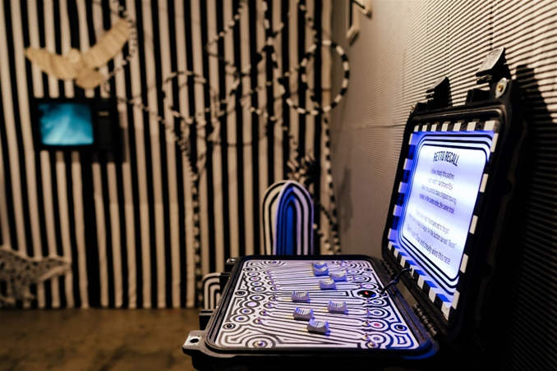

There is also a ‘PUP QUEST’ and a ‘COLOUR CONUNDRUM’ that you can complete. Your guidebook will tell you more about these.

Some of the games make a noise.  We will turn them on for you when you’re ready. | Some of the games have colourful, flashing lights.
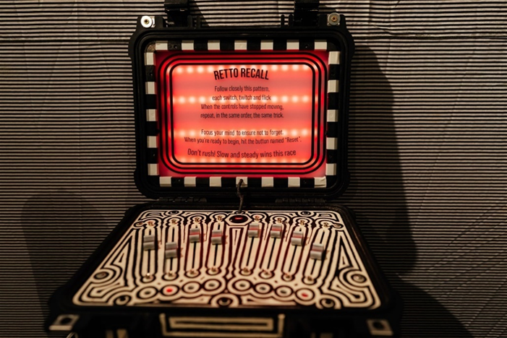
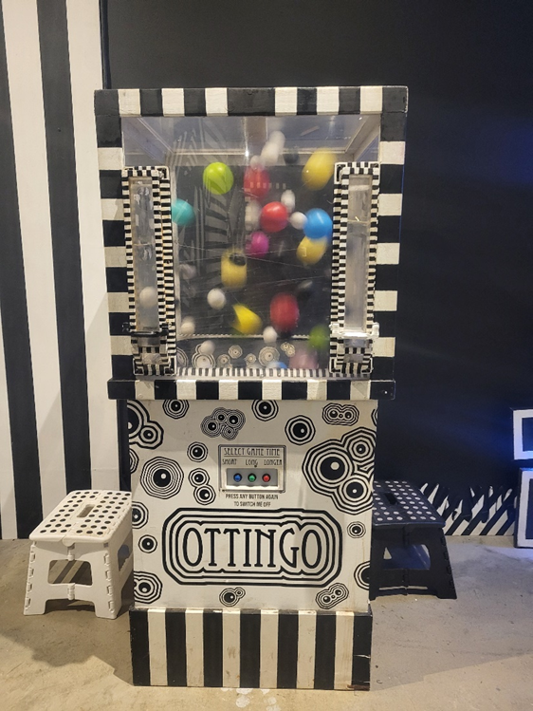

If you are sensitive to noise, please ask the gallery assistant if you can borrow some ear defenders.

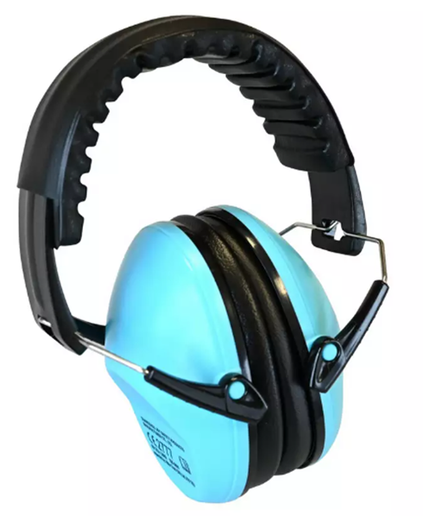

If you need a quieter space at any point during your visit, there is a room upstairs at the far end of the corridor called The Lookout Studio that you can use.

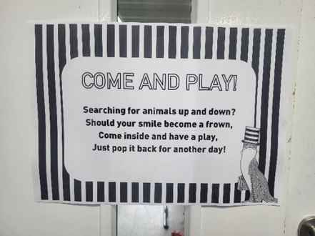
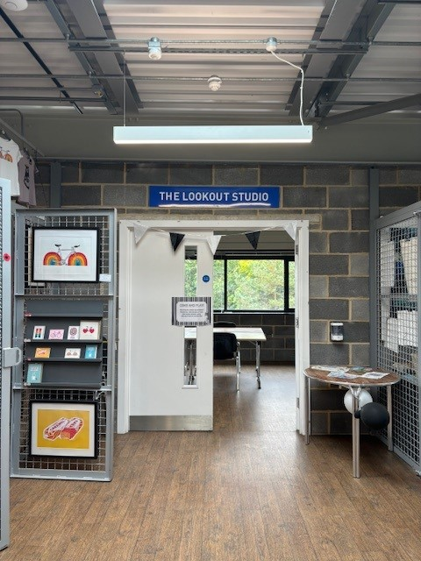

The quiet room has a place to sit and some games to play. Stay as long as you need/want.

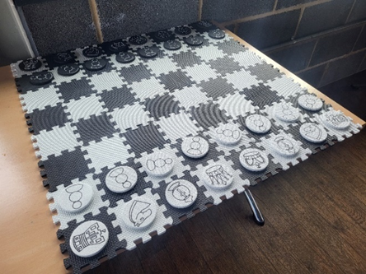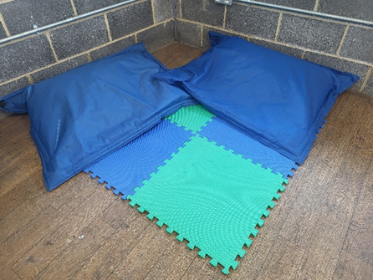

You can also go upstairs whilst completing the ‘spOTTER QUEST’ and look at our resident artists’ studios.
There is also a lift that you can use instead of the stairs. (It is quite slow though!)
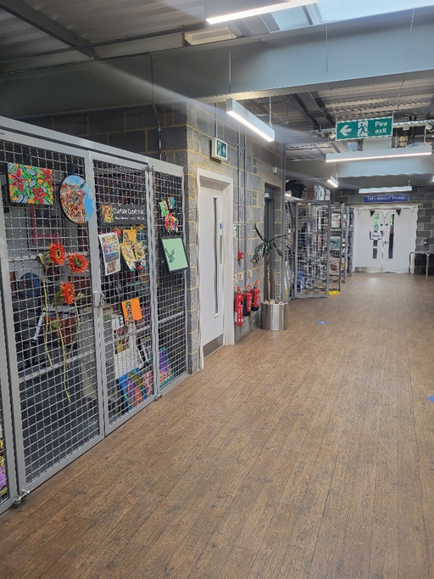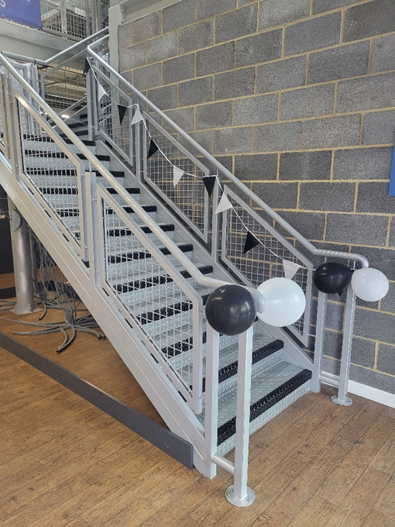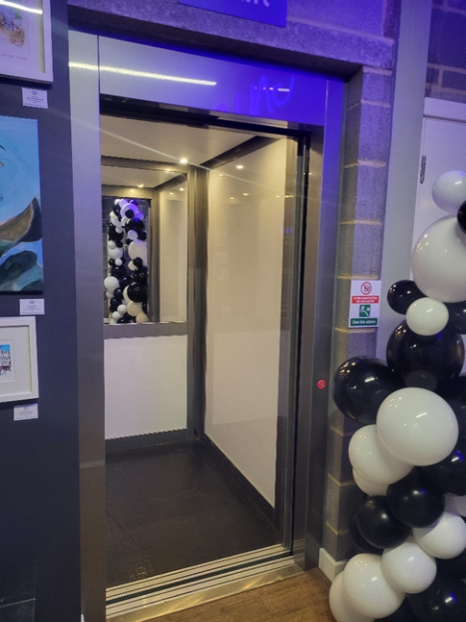

There is a café at The Base. Strong smells, like coffee or hot food, may spread out of the café in to the rest of the building.

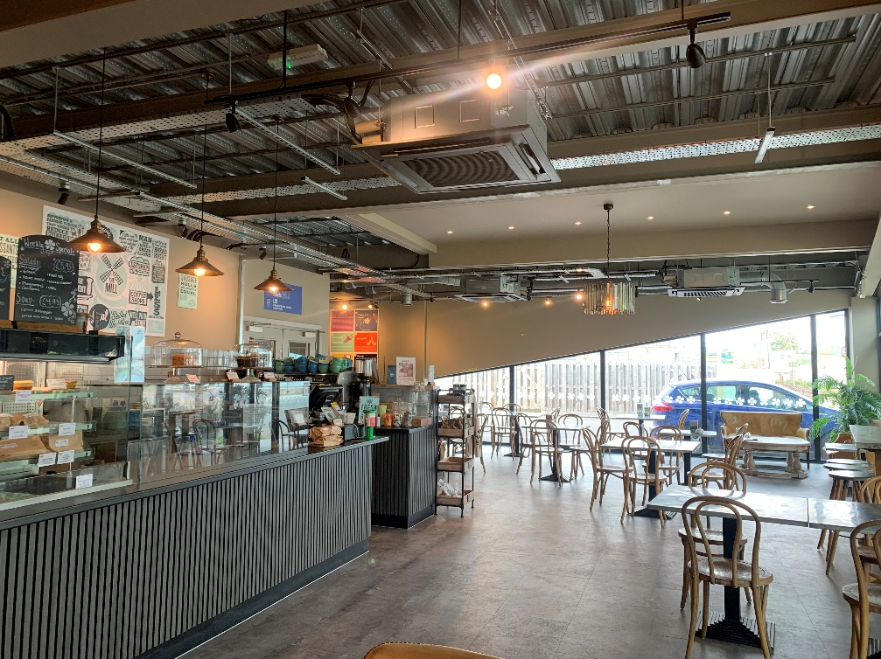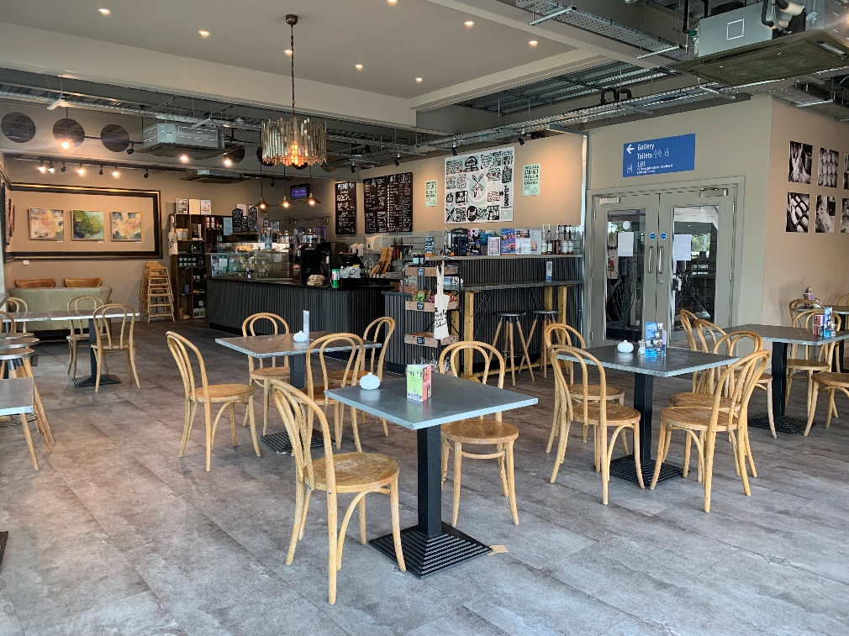

Inside the café can be busy and noisy with loud coffee machines and lots of customers talking.
We hope you enjoy your visit to The Base.

If there is anything we can do to make your visit more comfortable, please speak to a member of our team or email admin@thebasegreenham.co.uk

