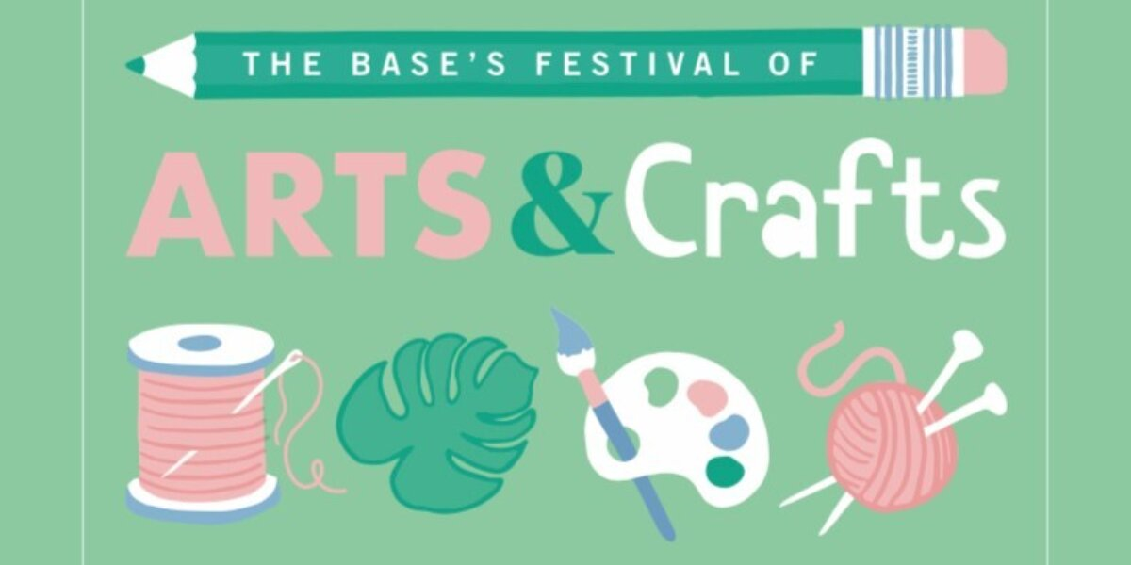

THE BASE’S FESTIVAL OF ARTS AND CRAFTS

APPLICATION FORM

**Full Name \***

**Business Name** (if different)

**First Line of Address\***

**Second Line of Address**

**Town / City \***

**County**

**Postcode \***

**Email Address \***

**Telephone Number \***

**Website Address?**

**Social Media Accounts?**

**The images you submit should be the work you are wanting to exhibit in our Gallery space. There is a 15% commission taken on any sales that are made during The Base’s Festival of Arts and Crafts.**

**Please tell us about your work**\* (Please do this for each individual work that you are submitting)

**Title**:

**Year it was made**:

**Price**:

**Medium**:

**Title**:

**Year it was made**:

**Price**:

**Medium**:

**Title**:

**Year it was made**:

**Price**:

**Medium**:

**Please let us know anything else that we may find interesting i.e. dimensions, techniques and where did you study?** (250 words max)

**Please email this form in, along with 3 digital images of your work, to** [**admin@thebasegreenham.co.uk**](mailto:admin@thebasegreenham.co.uk) **by Sunday 13 March at 9pm.**

**Images should be saved as JPEG files and please name each image e.g. SecondNameFirstName_TitleOfYourWork.jpg \***

If your work is selected please note key dates are as follows:

Tuesday 5 April – Drop off date (to drop your work of at The Base, so we can curate and hang the exhibition) 10am – 2pm

Tuesday 19April – Collection day (to collect your work from The Base)