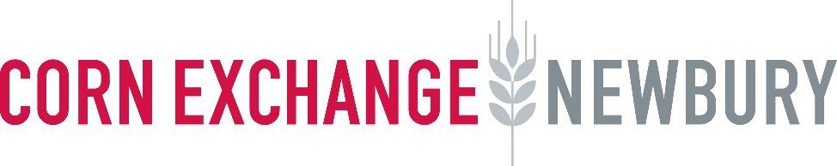
Work Experience with the Corn Exchange
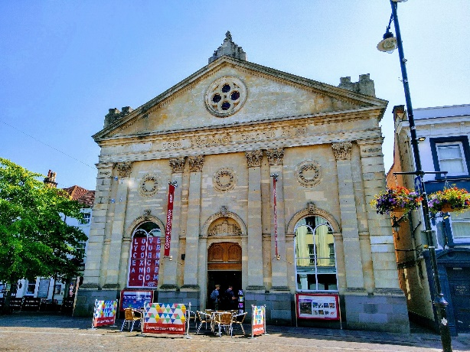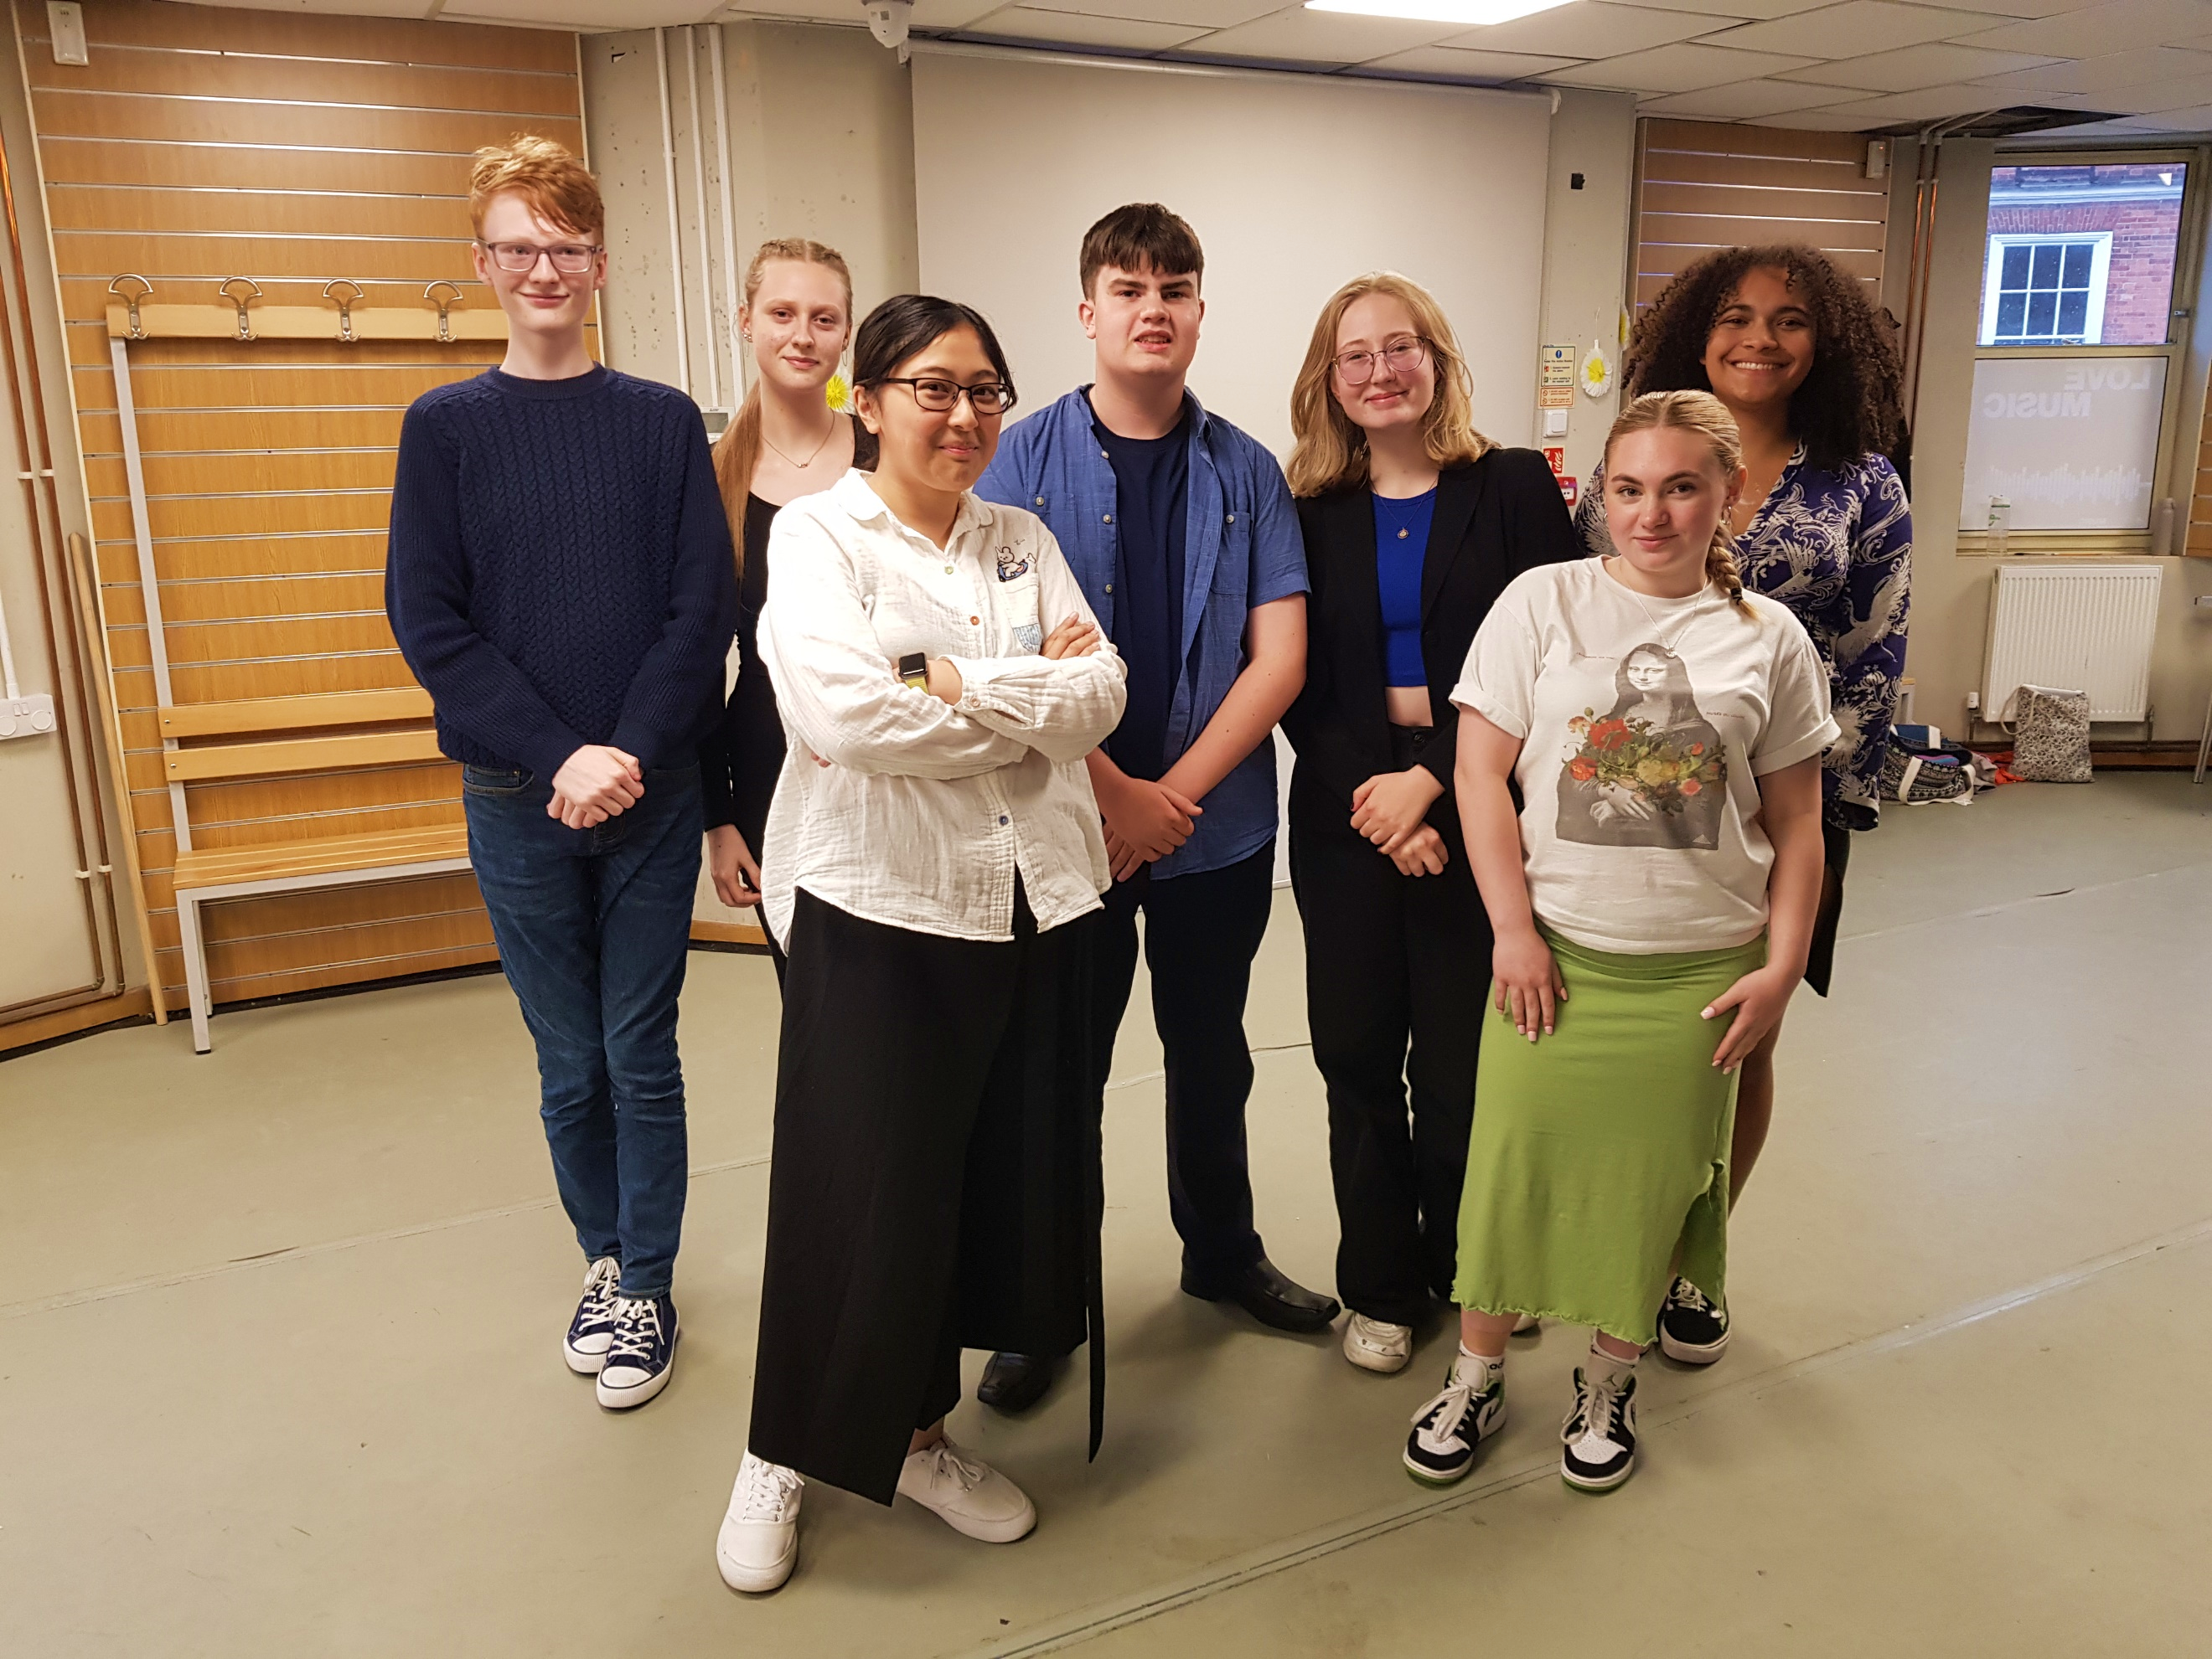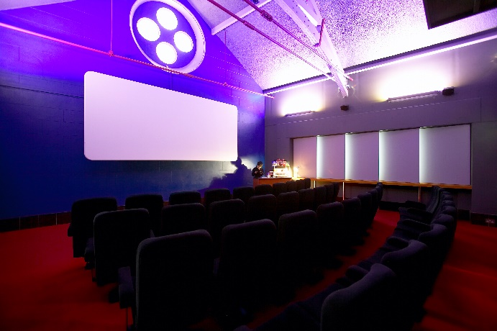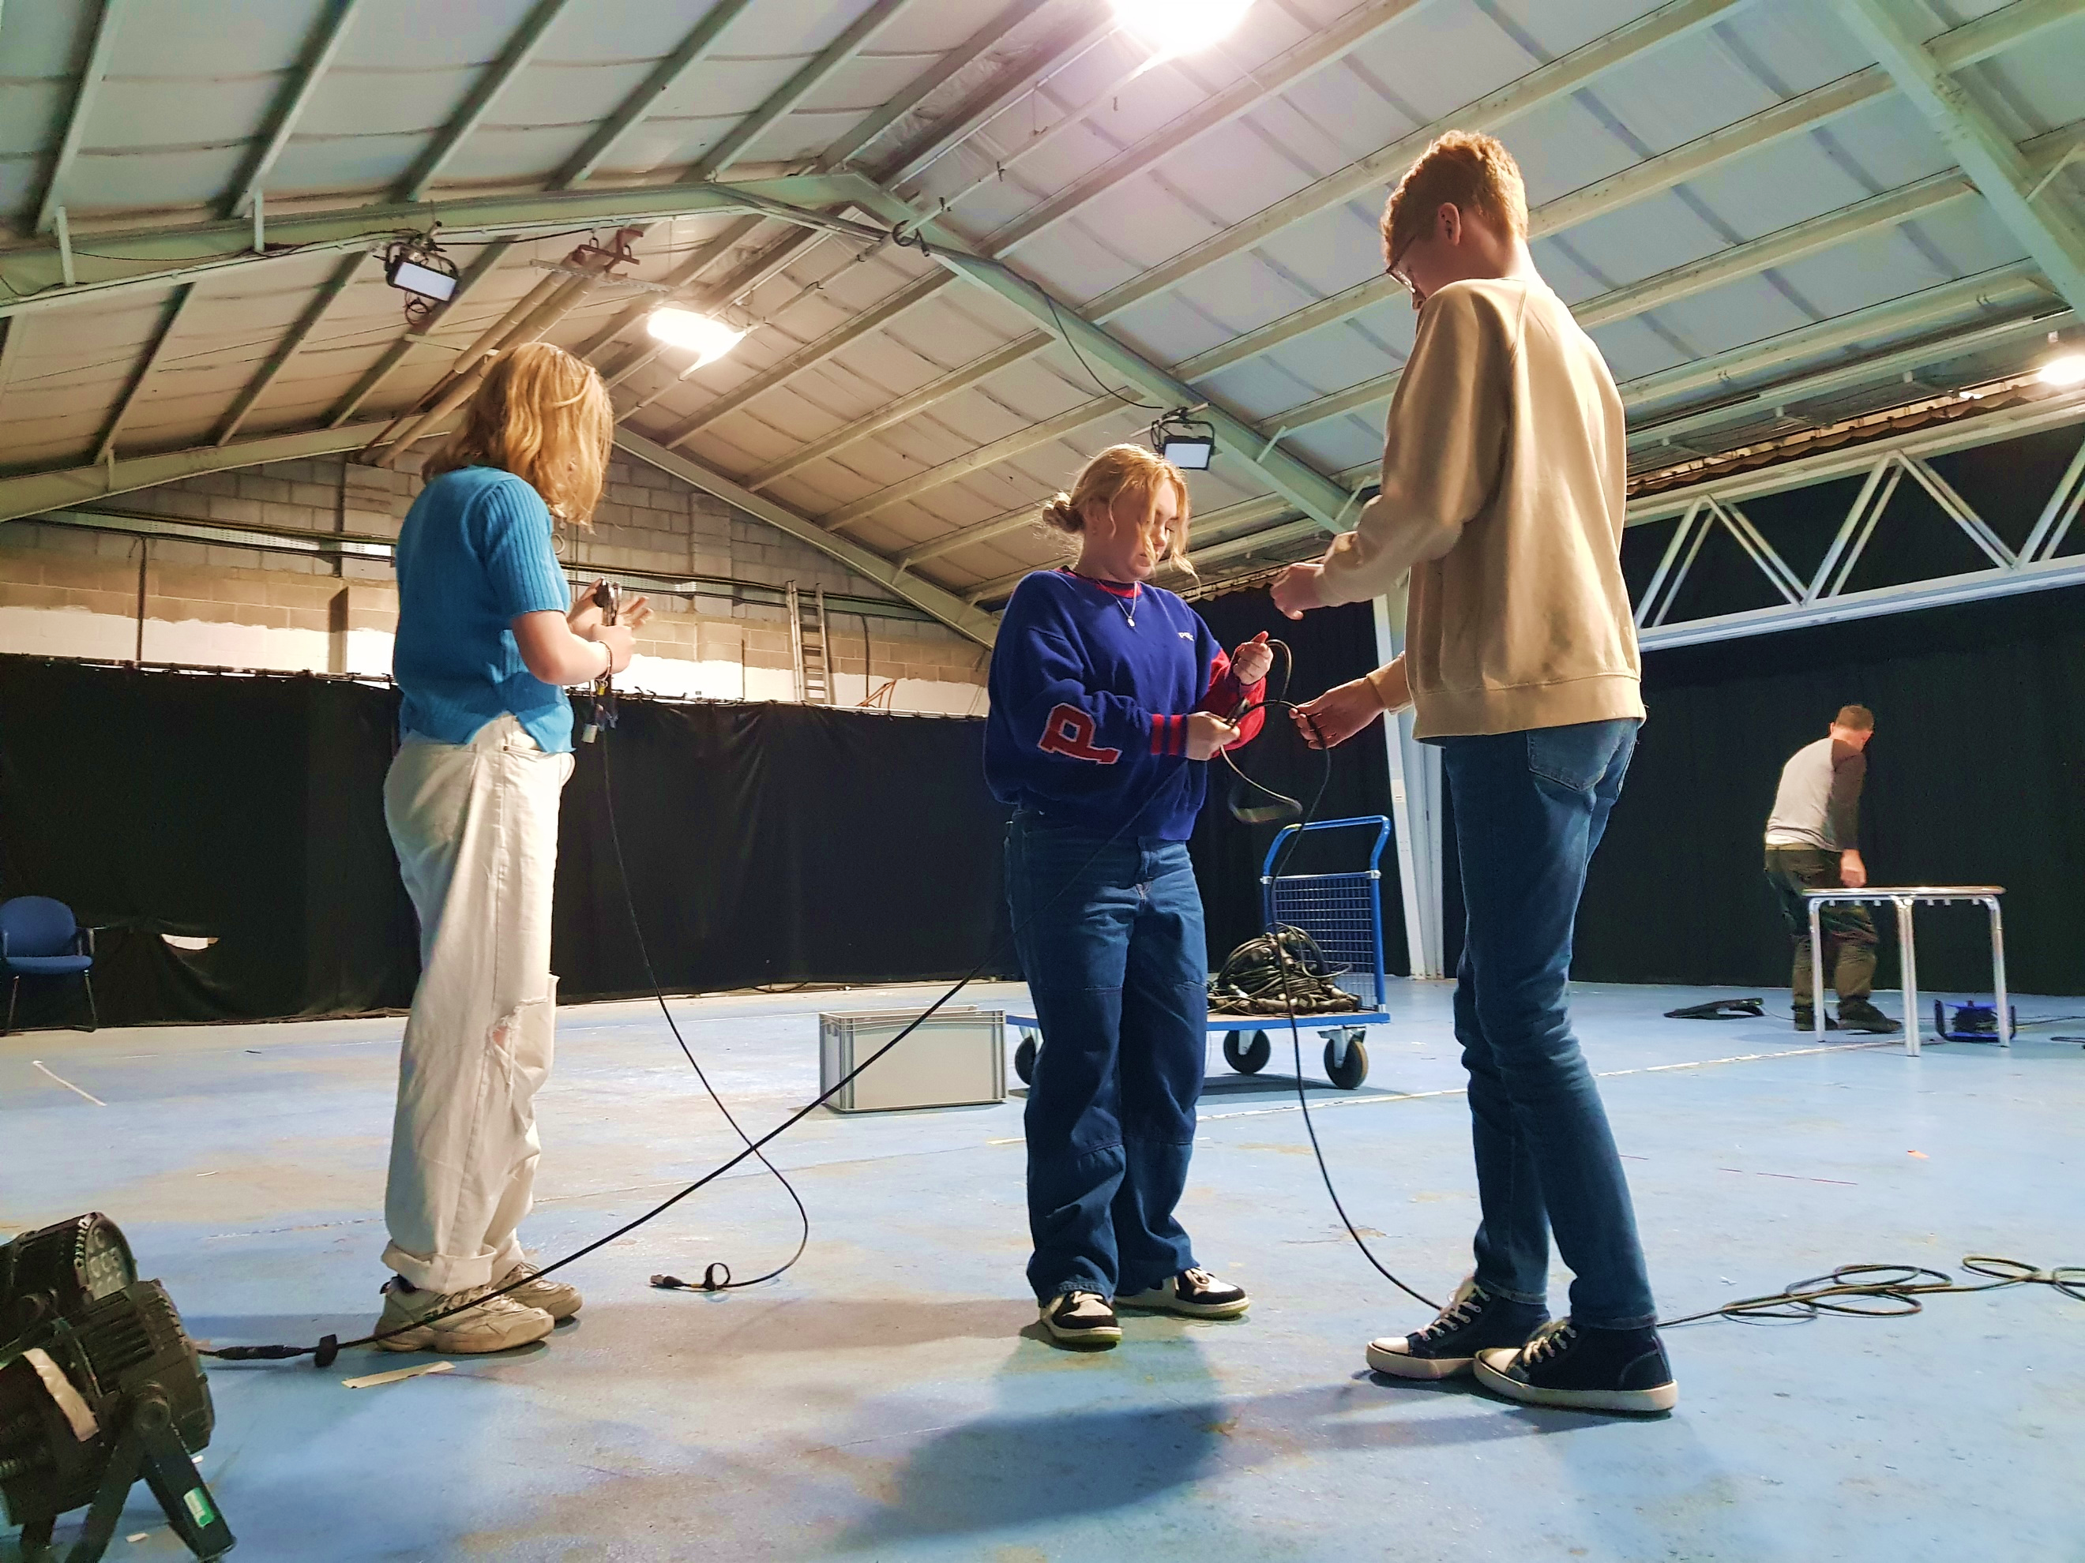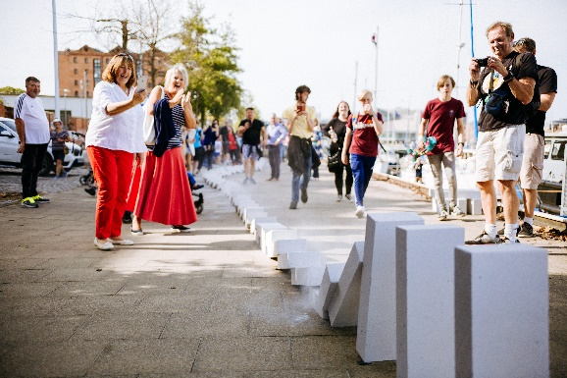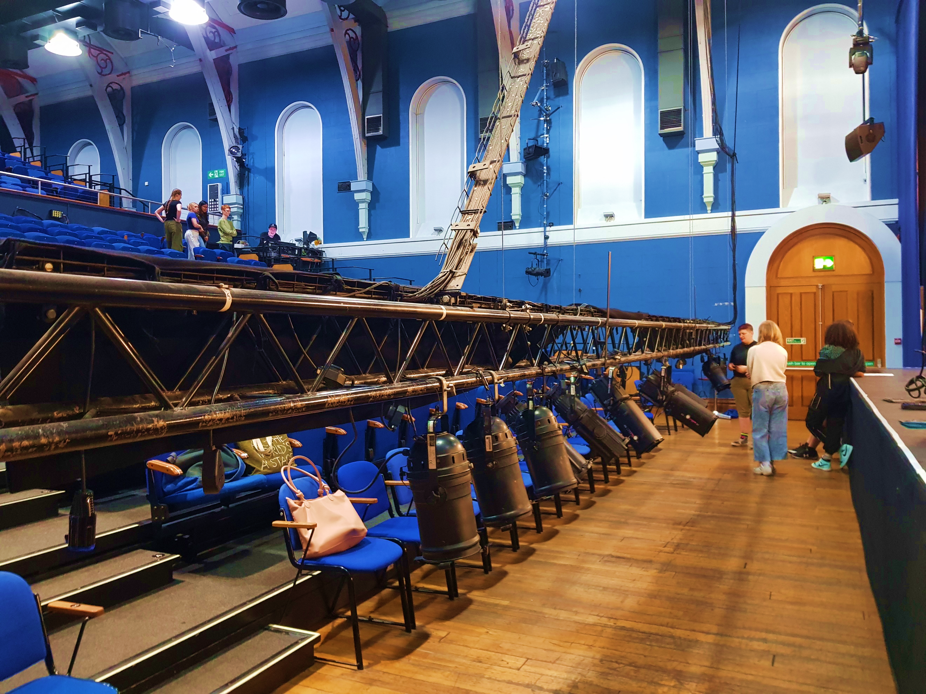

Are you passionate about a future in the arts?
Are you looking for a high quality, creative and engaging work experience week?

We are opening our doors for one extra-special week in July 2026, to give twelve young people from across West Berkshire a creative, collaborative and engaging work experience week that they won’t forget.
Our work experience week is open to students in Year 10/11 who are passionate about a future in the arts and who can demonstrate current engagement with arts and cultural activities.

When Is Work Experience Week?
Monday 13 – Friday 17 July 2026
9.30am – 3.30pm each day

What does our Work Experience involve?
Time with every Corn Exchange department, including The Base and 101 Outdoor Arts, to learn the integral role each department plays in the running of a receiving, community theatre.
Opportunities to engage with and participate in our live programme of shows and classes.
The chance to work on a bespoke, creative arts project to be presented on the final day to members of the Corn Exchange team as a celebration of your time with us!

Where will students be based for the week?
Work Experience with the Corn Exchange will take place predominantly in our designated learning and participation space, the Old Library.
However, on one of the days, participants will be based at The Base & 101 Outdoor Arts National Centre for Arts in Public Space at Greenham Business Park.

The Application Process:
To apply for Work Experience with the Corn Exchange, please fill out an application form by following this link:
Work Experience Application Form - July 2026 – Fill in form
The deadline for applications is 10am on Monday 2 March 2026.
If your application is successful, we will invite you to an informal interview after school w/c 16 March 2026.

For further information, please contact the Learning and Participation team at:
getinvolved@cornexchangenew.co.uk | 01635 582666

